JOIN CHINESE CLUB FOR FUN
Class Code:ej27dqe

Activities:  - Ping-Pong Tournament  In Lily Yip Table tennis center.  - Chinese Holiday Celebrations  - Sushi Tasting  - Korean Food  - International Food Day | 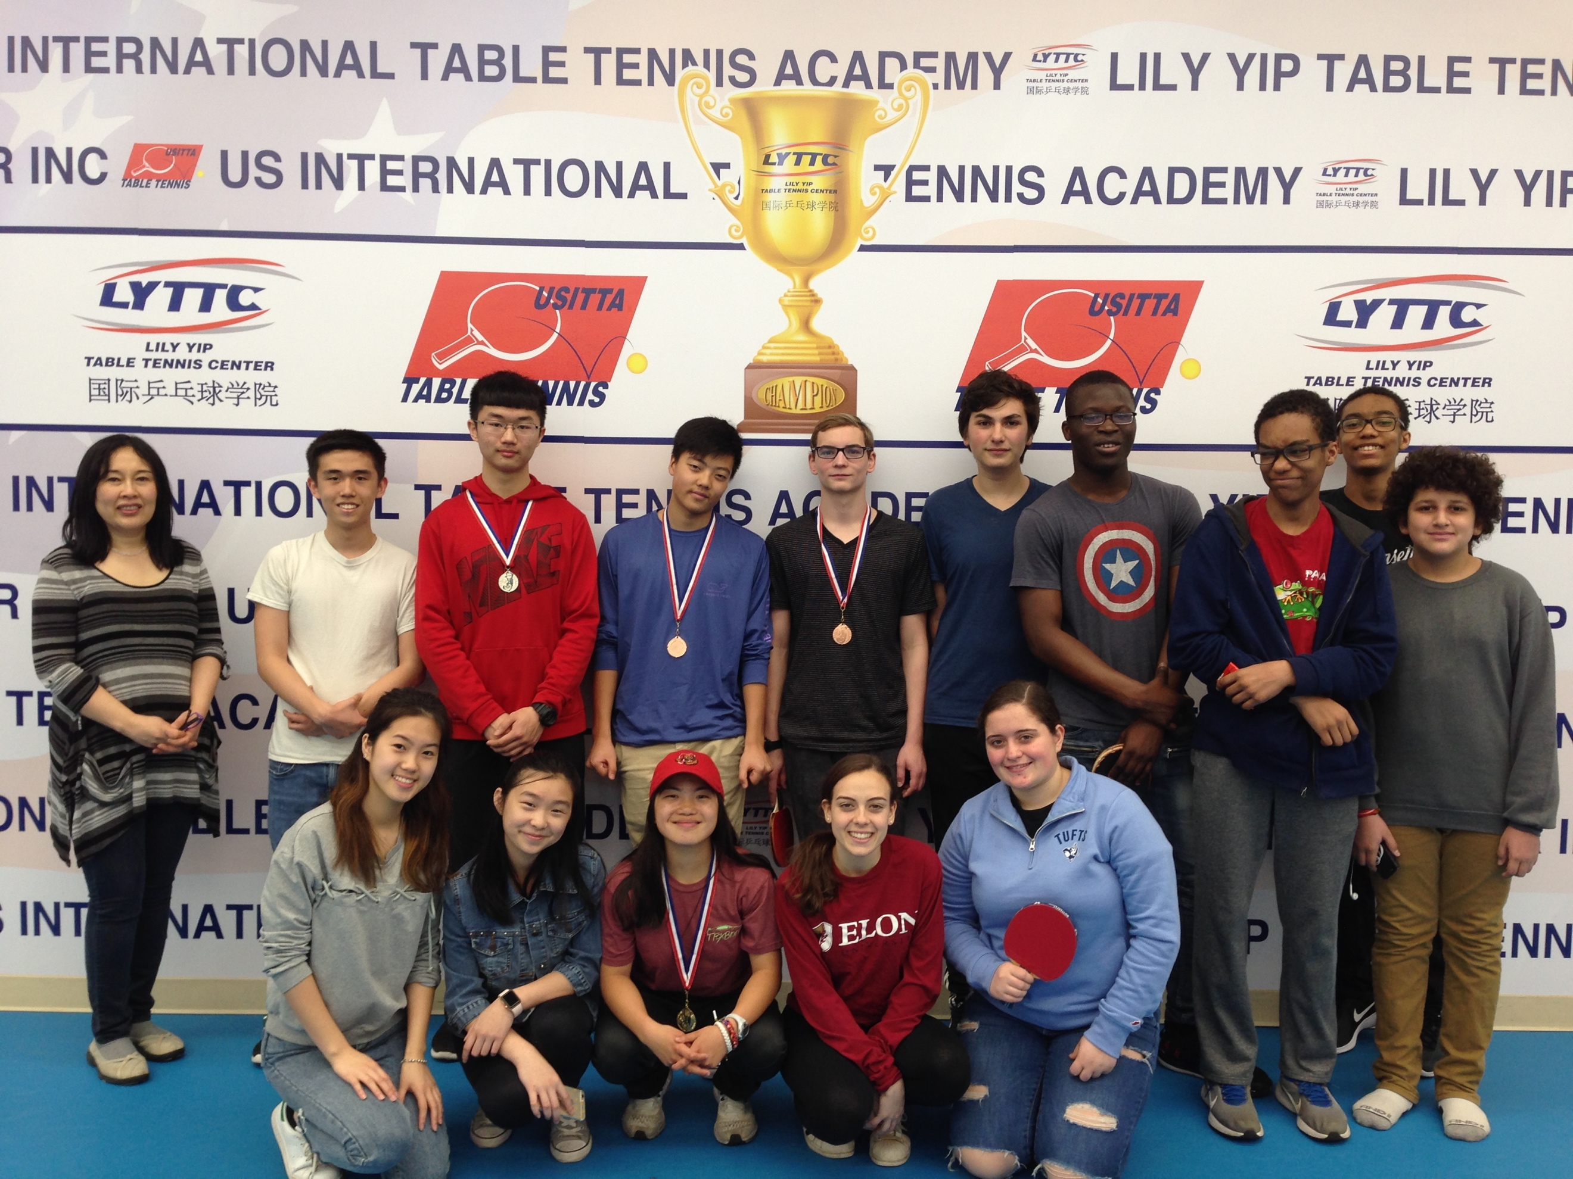  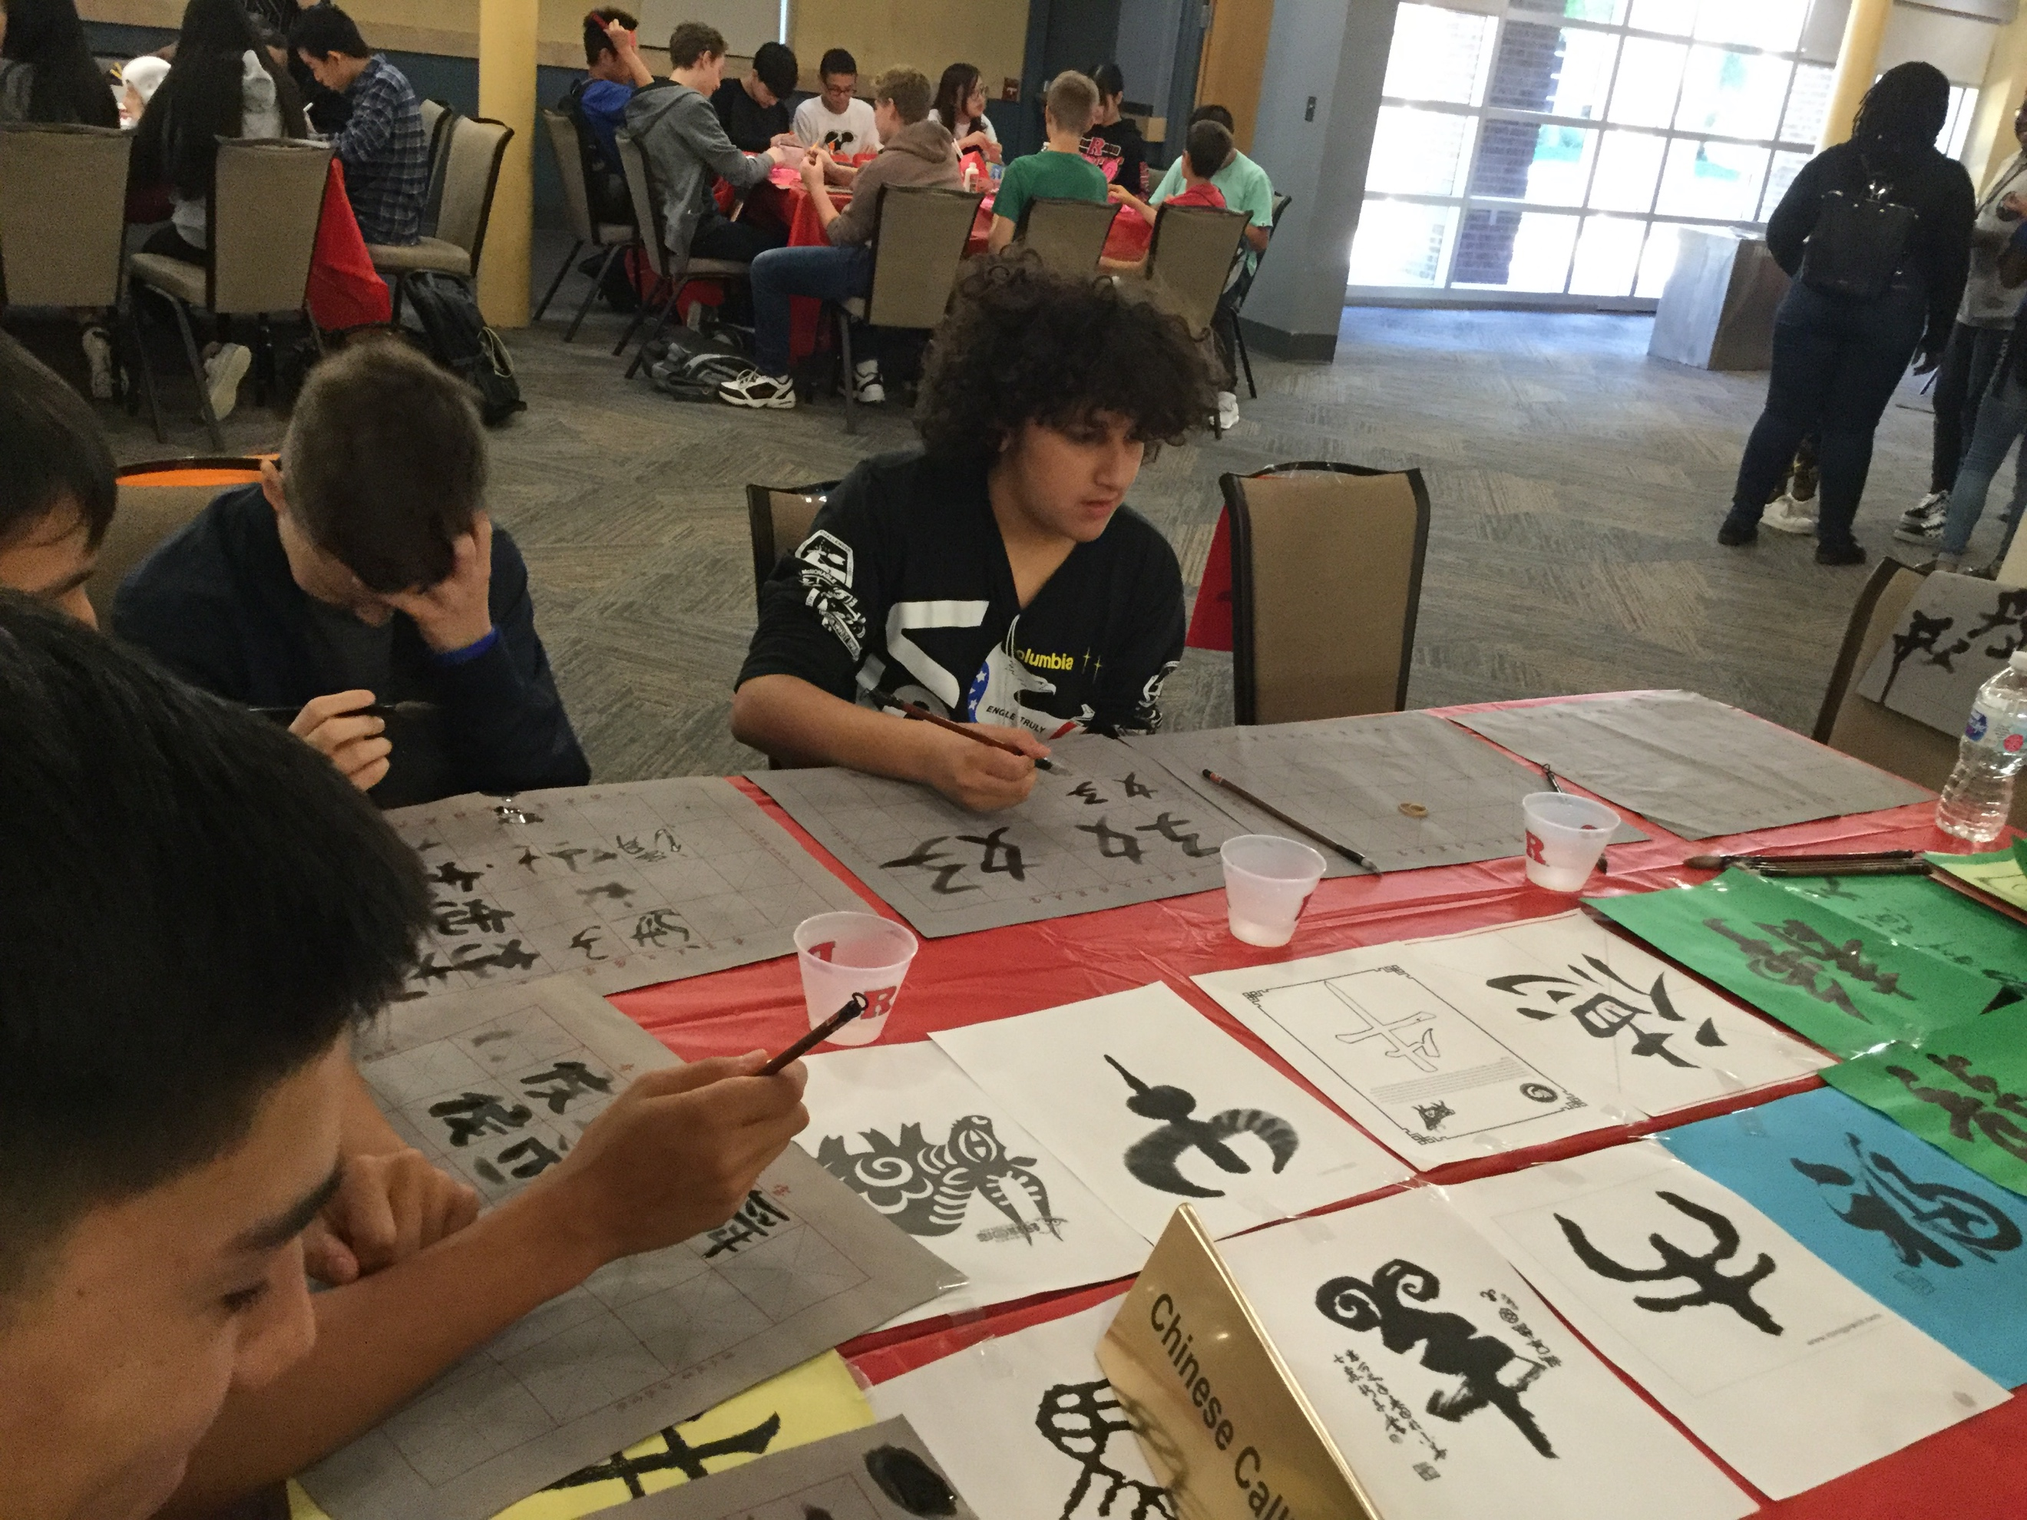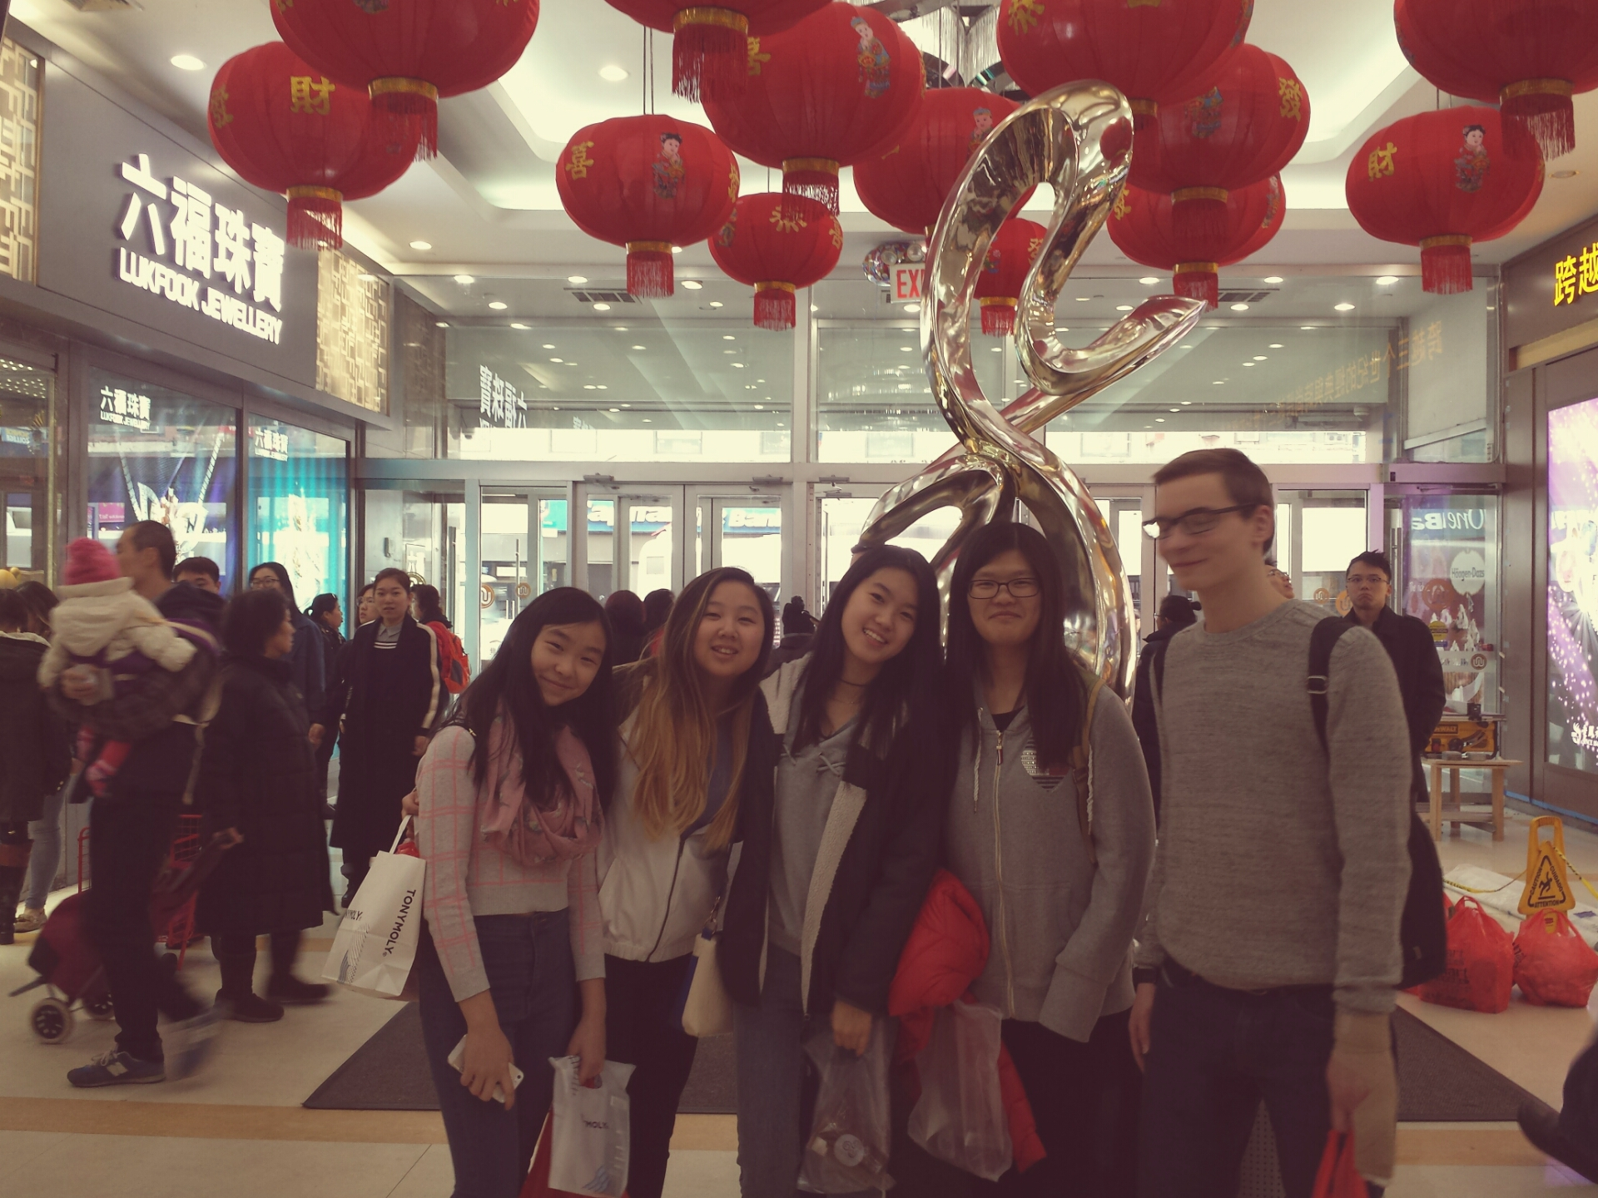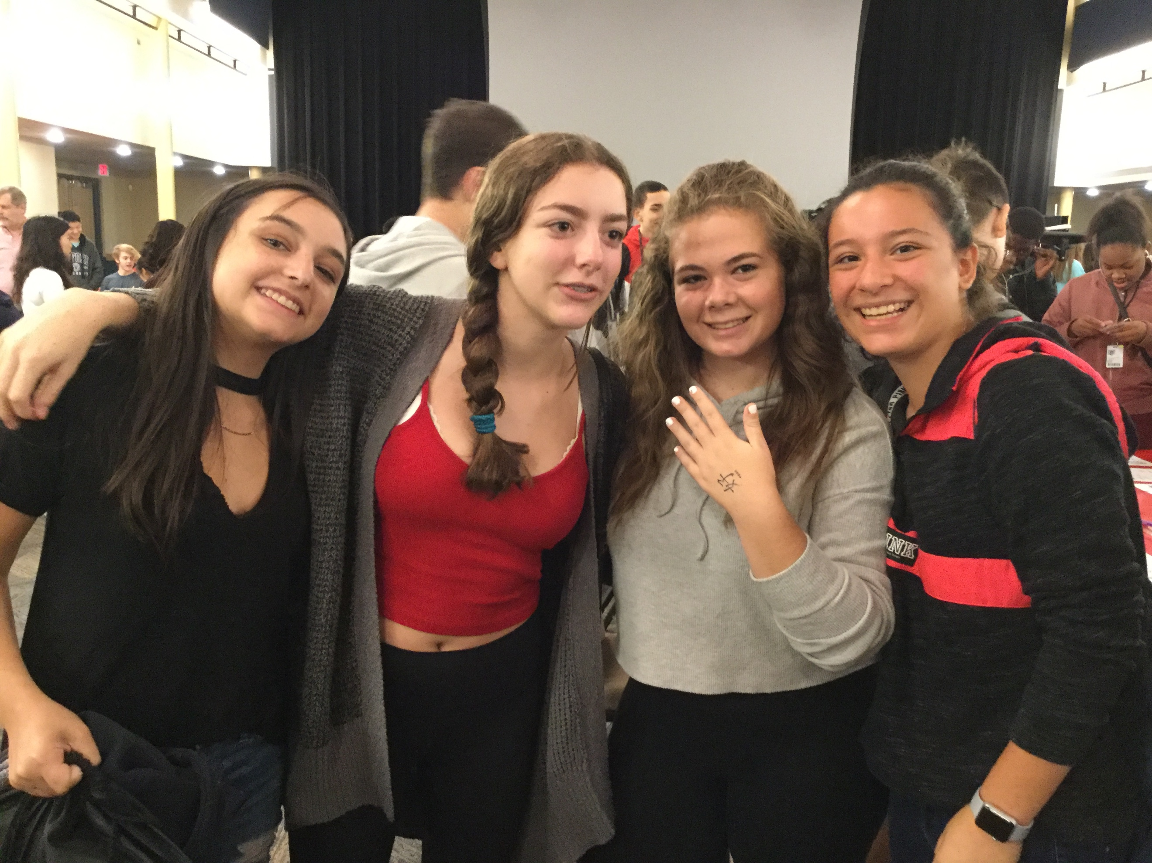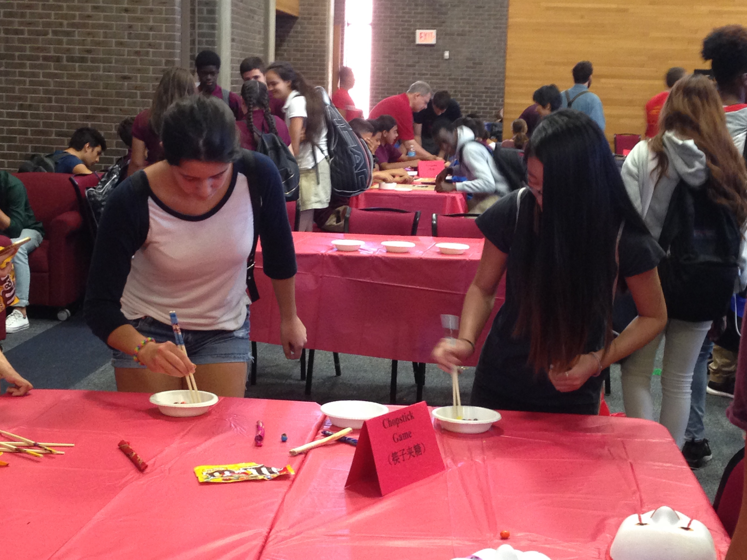 | COMMUNITY Service  Activities:  - Fundraisers  - Donation Bins for people needed  - Back to School  - Homecoming
Chinese Honor Society Requirements:  - Must be a member of Chinese club.  - Must complete 4 service activities each year that you are in the club.  - Must maintain the proper grade | Annual Field Trips:  - Chinatown Flushing,  - Lily Yip Table Tennis  - Rutgers Culture Day  RESUME BOOSTER  FOLLOW US ON Instagram: | Each month, the 2nd Thursday/ Cafeteria/ play Ping-Pong. The 4th Thursday/ Room 236 to learn about Chinese/Asian cultures:  - Chinese knotting  - Calligraphy  - Origami  Remote:  Google Classroom: ej27dqe

The membership is open to all students in Scotch Plains-Fanwood high school. The parents need to sign permission slip.
Location to meet:

2nd Thursday of every month | 4th Thursday of every month
Freshman Cafeteria | Room 281

The membership fee $5 in check or cash!

Please print and sign the payment sheet below, also please list any known food allergies that you have.

Chinese /Ping-Pong & Honor Society PAYMENT SLIP

I paid $5 to attend Chinese/Ping –Pong Club in Cafeteria and Room 281 from 2:25 to 3:15 on 2nd and 4th Thursdays every month.

Please list any known food allergies that you might have:

Full name ( Print) ___________________ Signature ___________________
Date ___________________

